Abstract Template for the 4th INTERNATIONAL WORKSHOP ON PLASMA AGRICULTURE (Times New Roman 16, bold, centered)

Ihn Han^{1,2} and Eun Ha Choi^{1,2} (Times New Roman 12, bold, centered)
¹Plasma Bioscience Research Center, KwangWoon University, Korea
²Department of Electronic and Biological Physics, KwangWoon University, Korea
(Times New Roman 11, italic, centered)

Abstracts must be in English and should report new previously unpublished work. The total length, including figures and all references, is limited to A4 format single page (all types of contributions - plenary, invited, contributed oral lectures as well as for posters). Please follow the requested format of the abstract template. The abstracts that will not conform the format may be rejected. It is recommended to submit the abstract in electronic form via conference website (‘abstract submission’ link). The submitted abstract must be a Microsoft Office Word file (*.doc, *.docx) and PDF file.
※ Deadline for Abstract Submission is March 31, 2023
All submitted abstracts will be referred by the Local Organizing Committee and Technical Program Committee. Based on their scientific quality and relevance to the conference topics, the abstract will be either accepted for publication in the Book of Abstracts or rejected.

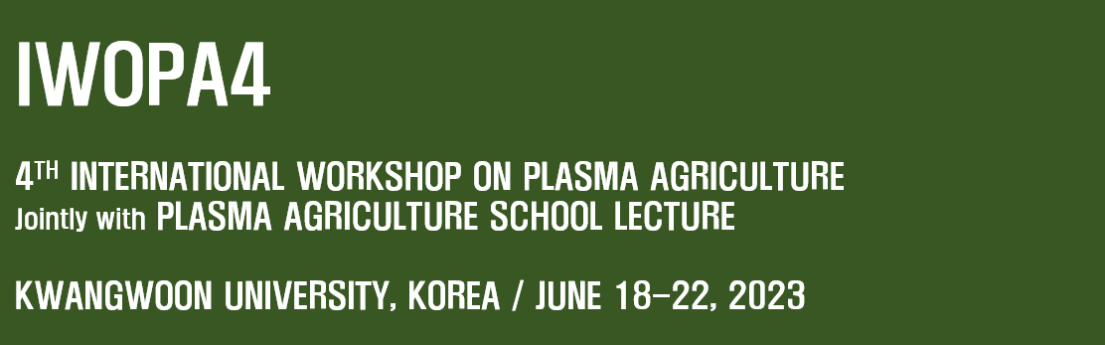
Fig. 1 Plasma Agriculture

General recommendations for the format of the abstract
The abstract should be typewritten for A4 format paper, maximum one page for all contributions.
- Margins: Top: 3cm, Bottom: 2.5cm; Left and Right: 2cm. Please respect the margins!
- Font: Times New Roman. Title: 16pt, bold, centered. Authors names: 12pt, bold, centered. Affiliations: 11pt, italic, centered. Main text: 12pt, justified left and right.
- Figures and Photos: Abstract may include figures and photographs. A caption should be attached to each figure. Caption style: Fig. 1. Your text.
- Acknowledgement: Times New Roman, 12pt. After the main text and before the references (separated by empty lines).
- Citations: Times New Roman, 12 pt. Cite references using square brackets [1-4]. Examples of the format to be used are given below.

References
[1] A. Author, B. Author, and C. Author, Journal, Volume, Page (Year).
[2] A. Author, Title of Book, Publisher, City (Year).
[3] A. Author and B. Author, Conference, Dates, City, Country, Page (Year).

